Creating a Skin MyGUI 3.0.0

Part 2 - skin celebrated flag (CheckBox)

The last time we looked at the creation of a button. The check box is also a button, but as a rule, in addition to his four major states, there are four that are shown when the flag is a property that it is marked (Checked):
- «Disabled» - button is disabled, the user does not have access to it.
- «Normal» - the usual state of the button.
- «Highlighted» - the button is highlighted, the user is brought to click the mouse.
- «Pushed» - button is pressed, the user presses the mouse button.
- «Disabled_checked» - button is disabled, the user does not have access to it (the button is marked.)
- «Normal_checked» - the usual state of the button (the button is marked.)
- «Highlighted_checked» - the button is highlighted, the user is brought to click your mouse (button is selected).
- «Pushed_checked» - button is pressed, the user presses the mouse button (the button is marked.)

Imagine that when you create a check box, we need to take into account the fact that information explaining the importance of flags can be placed in several rows. Here's a rough concept of a skin check boxes:
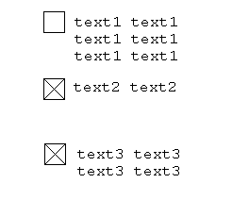

To begin with we will ask the artist to paint a texture with the image of a check box in all eight states. Rename (if necessary) texture «MyCheckBox.png» and copy the resources folder. That's what I came up:
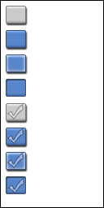

First let's define the size. Our skin is composed of sabskina displays a texture that will always be attached to the upper left corner and will not stretch. In the skins will attend second sabskin displaying text. It will be the right of first sabskina and stretch along with the skin. Between the first and second sabskinom is a short distance, for a better visual display of text.
So, open texture and outline of sufficient size for the skin. I have turned 69 by 25 pixels. In this case, the width of the skin does not matter, but it is desirable to make it visually quite well visible, it will facilitate the creation of the skin and support in the editor:
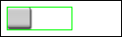

Create a file «MyCheckBox.xml», copy it to a folder of resources and describe it to our billet skin:

<?xml version="1.0" encoding="UTF-8"?>
<MyGUI type="Resource" version="1.1">

<Resource type="ResourceSkin" name="MyCheckBox"
size="69 25" texture="MyCheckBox.png">
</Resource>

</MyGUI>

Now add the first sabskin. Open the texture editor and note the size and position of the first sabskina:

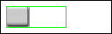
First sabskin starts at position 0 on the left and 0 at the top and has a width 27 and height of 25 pixels. To sabskin always remained in the corner, you must specify the alignment «Left Top»:

<Resource type="ResourceSkin" name="MyCheckBox"
size="69 25" texture="MyCheckBox.png">
<BasisSkin type="SubSkin" offset="0 0 27 25" align="Left Top">
</BasisSkin>
</Resource>

To make our skin was visible, create a condition called «normal» and specify texture offset:

<Resource type="ResourceSkin" name="MyCheckBox"
size="69 25" texture="MyCheckBox.png">
<BasisSkin type="SubSkin" offset="0 0 27 25" align="Left Top">
<State name="normal" offset="7 7 27 25"/>
</BasisSkin>
</Resource>

In our case, the size and texture sabskina matches and is 27 by 25 pixels in the texture and the position is equal to 7 and 7, top left pixel.

Now add the code and try to create our button:

MyGUI::Gui::getInstance().load("MyCheckBox.xml");
MyGUI::Button* button =
MyGUI::Gui::getInstance().createWidget<MyGUI::Button>(
"MyCheckBox",
MyGUI::IntCoord(30, 30, 130, 40),
MyGUI::Align::Default,
"Main");

If you did everything correctly then the box should look like this:

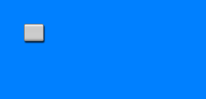

Our flag is not pressed and is not marked and has no text. It's time to add text sabskin. To begin, select a texture, and mark the position of text in the skin:

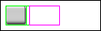

I got 30 left and 0 pixels from the top, width 39 and height 25 pixels. I recall that the shift is relatively sabskinov itself and not the skin texture. The alignment will have sabskina «Stretch» ​​because we want the text to always fill the entire skin. The color white indicate «# FFFFFF». In order to correct the text appeared, The properties of the skin indicate the default font «Default»:

<Resource type="ResourceSkin" name="MyCheckBox"
size="69 25" texture="MyCheckBox.png">
<Property key="FontName" value="Default"/>
<BasisSkin type="SubSkin" offset="0 0 27 25" align="Left Top">
<State name="normal" offset="7 7 27 25"/>
</BasisSkin>
<BasisSkin type="SimpleText" offset="30 0 39 25" align="Stretch">
<State name="normal" colour="#FFFFFF"/>
</BasisSkin>
</Resource>

Now add some text in the box and see what we have:

MyGUI::Gui::getInstance().load("MyCheckBox.xml");
MyGUI::Button* button =
MyGUI::Gui::getInstance().createWidget<MyGUI::Button>(
"MyCheckBox",
MyGUI::IntCoord(30, 30, 130, 40),
MyGUI::Align::Default,
"Main");
button->setCaption("MyCheckBox");

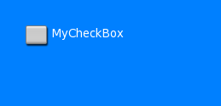

When the widget is stretched and the stretching of the skin, but as we pointed out first sabskinu position without stretching, it is not stretched. Starting position skins:

After stretching the skin as follows:

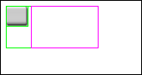

Let's show the flag in a few lines:

MyGUI::Gui::getInstance().load("MyCheckBox.xml");
MyGUI::Button* button =
MyGUI::Gui::getInstance().createWidget<MyGUI::Button>(
"MyCheckBox",
MyGUI::IntCoord(30, 30, 130, 40),
MyGUI::Align::Default,
"Main");
button->setCaption("MyCheckBox1\nMyCheckBox2");

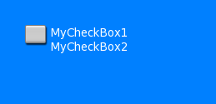

Thus, the foundation of our flag is ready, it remains to add the all of our state and check their work. In our texture difference between the states is 30 pixels in height, we use this regularity, and add the remaining states:

<Resource type="ResourceSkin" name="MyCheckBox"
size="69 25" texture="MyCheckBox.png">
<Property key="FontName" value="Default"/>
<BasisSkin type="SubSkin" offset="0 0 27 25" align="Left Top">
<State name="disabled" offset="7 7 27 25"/>
<State name="normal" offset="7 37 27 25"/>
<State name="highlighted" offset="7 67 27 25"/>
<State name="pushed" offset="7 97 27 25"/>
<State name="disabled_checked" offset="7 127 27 25"/>
<State name="normal_checked" offset="7 157 27 25"/>
<State name="highlighted_checked" offset="7 187 27 25"/>
<State name="pushed_checked" offset="7 217 27 25"/>
</BasisSkin>
<BasisSkin type="SimpleText" offset="30 0 39 25" align="Stretch">
<State name="disabled" colour="#FFFFFF"/>
<State name="normal" colour="#FFFFFF"/>
<State name="highlighted" colour="#FFFFFF"/>
<State name="pushed" colour="#FFFFFF"/>
<State name="disabled_checked" colour="#FFFFFF"/>
<State name="normal_checked" colour="#FFFFFF"/>
<State name="highlighted_checked" colour="#FFFFFF"/>
<State name="pushed_checked" colour="#FFFFFF"/>
</BasisSkin>
</Resource>

Now add in the code by pressing a response to our changed status check:

MyGUI::Gui::getInstance().load("MyCheckBox.xml");
MyGUI::Button* button =
MyGUI::Gui::getInstance().createWidget<MyGUI::Button>(
"MyCheckBox",
MyGUI::IntCoord(30, 30, 130, 40),
MyGUI::Align::Default,
"Main");
button->setCaption("MyCheckBox1\nMyCheckBox2");
button->eventMouseButtonClick = MyGUI::newDelegate(notifyMouseButtonClick);

And the handler itself:

void notifyMouseButtonClick(MyGUI::Widget* _sender)
{
MyGUI::Button* button = _sender->castType<MyGUI::Button>();
button->setStateCheck(!button->getStateCheck());
}

Now run and test work.

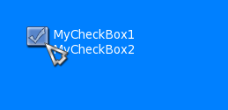

Congratulations, we have successfully created a skin for the celebrated flag!

